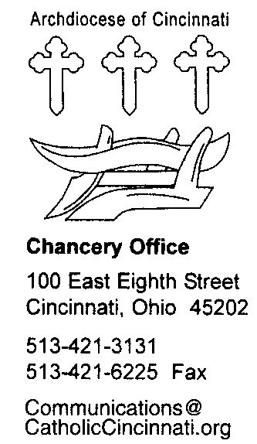
COUPLE’S INSERT FOR THE M-1 FORM

Directions: After you have seriously reflected on the following questions, please write your thoughtful answers after each item, or you could number them on a separate document. Work independently of your intended spouse. The parish minister helping you prepare for marriage will review your answers with you and address any questions you may have.

YOUR NAME _______________________________

SPIRITUAL ASSESSMENT:

- What is your religious background and training? Have you ever been baptized? Please be as specific and as detailed as possible.
- How do your religious beliefs influence the way you live your daily life? Please be specific.
- How are your religious beliefs influencing the way you are preparing for your approaching marriage?
- Are there any areas of religious difference between you and your future spouse? What religious tradition or beliefs are you planning to share with your children?
- How will your religious beliefs help you in your relationships with God and with your partner in marriage?
- What place do religious worship services have in your life? Do you attend worship services regularly, frequently, seldom, or never?
- Do you understand that only a marriage between a baptized man and a baptized woman is sacramental? What do you understand by the word, “sacrament?”
- Do you understand that you and your future spouse will be the ministers of matrimony to each other? What implications and consequences do you see for yourself and for your marriage?

PERSONAL ASSESSMENT:

- How long have you known your partner? Do you think you are able to communicate effectively?
- Do you believe that you are maturing? What signs of maturation do you notice in yourself? Are you satisfied with your present rate of progress in the maturation process?
- What is your understanding of each of the following topics: (a) marriage; (b) parenthood; (c) employment?
- Do you believe that you have adequate personal and financial resources to marry and begin a family? On what do your base your assessment?
- Have you been or are you now being treated for any mental or physical ailments? How would you assess your overall state of health?
- Do you have now or have you ever had problems with the abuse of alcohol or drugs?
- Do you believe that you and your future spouse are compatible in personality, character, temperament, and feelings? Why or why not?
- Describe your relationship with your prospective in-laws.
- Do you have any children from a previous relationship? If so, how many and does this fact influence your impending marriage?

CANONICAL ASSESSMENT:

- Have you ever been involved in any type of wedding ceremony? If so, has your freedom to marry been established either through the death of your former spouse(s) or through a declaration from a Catholic tribunal? Documentary evidence of your freedom to marry is required.
- Are you aware of any civil law or church law obstacles to your impending marriage? (Examples: blood relationship, religious vows, ordination, etc.).
- Are you marrying freely, that is, without force, coercion, and/or social pressure, parental pressure, or peer pressure, etc.?
- Do you intend to enter a lifelong, permanent covenant with your future spouse? Do you intend to be faithful in marriage, even in the face of serious and prolonged difficulties and/or illness?
- Are you open to children in your marriage?

